**Create a Static Website with Amazon Simple Storage Service (Amazon S3)**

1. **Create an S3 bucket**

For **Bucket name** I use fouzia-website-9876

To create the bucket and accept the remaining default values for **Object Ownership, Block Public Access settings** for this bucket, **Bucket Versioning and Default Encryption,** I choose **Create bucket .**

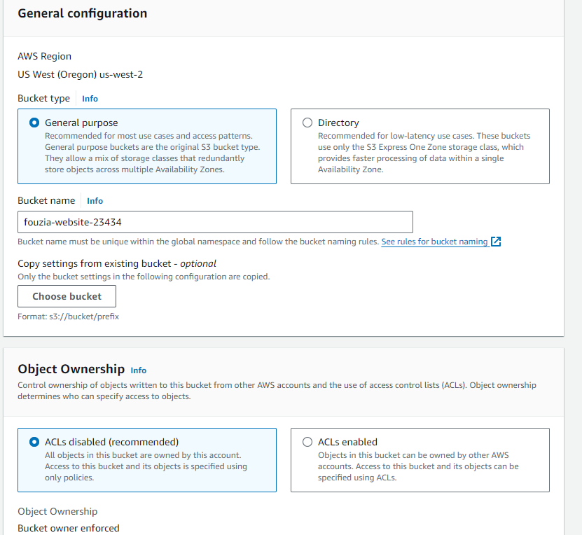

1. **Configure the S3 bucket as a static website and allow public access**

* **Configure the S3 bucket as a static website**

1. Choosing bucket that i just created.
2. Choosing the **Properties** tab.

* Under **Static website hosting**, choosing **Edit** -
* For the **Static website hosting** option, selecting **Enable**.
* For **Hosting type**, selecting **Host a static website**.
* For **Index document**, entering

• index.html

.

• For **Error document**, enter

* error.html

1. Choosing **save changes**.
2. Return to the **Static website hosting** section and for later reference, copy the value for the **Bucket website endpoint** into a text editor.

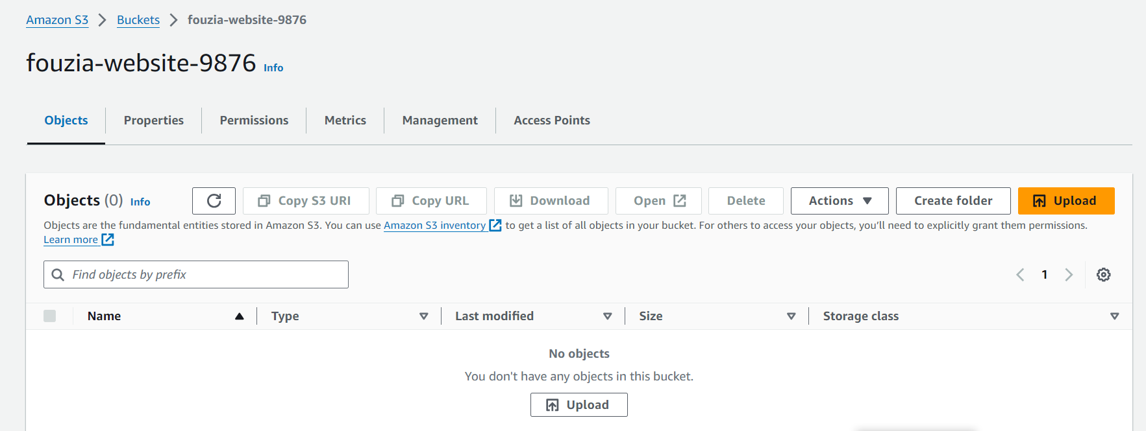

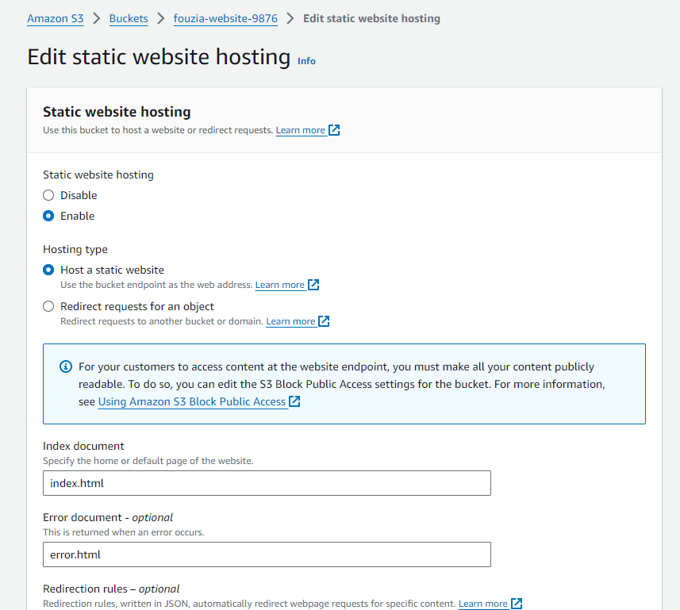

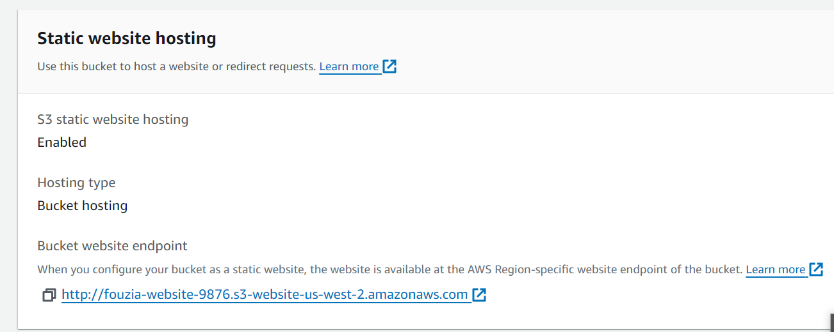

* **Allow public access to the bucket**
  1. In the page for the bucket i created, choosing the **Permissions** tab.
  2. From the **Block public access (bucket settings)** section, choosing **Edit** .
  3. I cleared **Block** *all* **public access**, and choose **save changes**.
  4. In the **Edit Block public access (bucket settings)** warning window, enter
  5. Confirm and choose **confirm**.

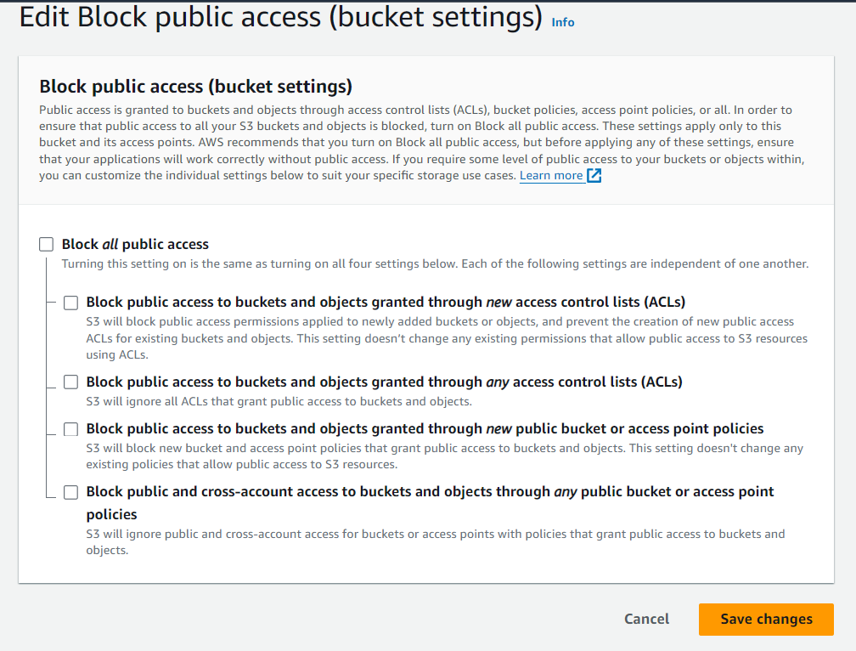

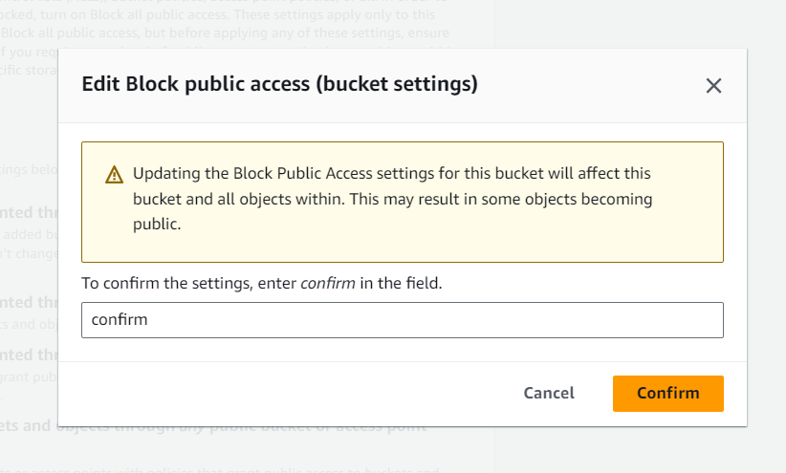

1. **Add a bucket policy to allow public access to content in your bucket**

* Choosing the **Permissions** tab.
* Under **Bucket Policy**, choosing **edit**.
* To grant **public read access** for our website, I just copy the following bucket , paste the policy.

{

"Version": "2012-10-17",

"Statement": [

{

"Sid": "PublicReadGetObject",

"Effect": "Allow",

"Principal": "*",

"Action": [

"s3:GetObject"

],

"Resource": [

"arn:aws:s3:::Bucket-Name/*"

]

}

]

}

I need to use **my creating** bucket name.

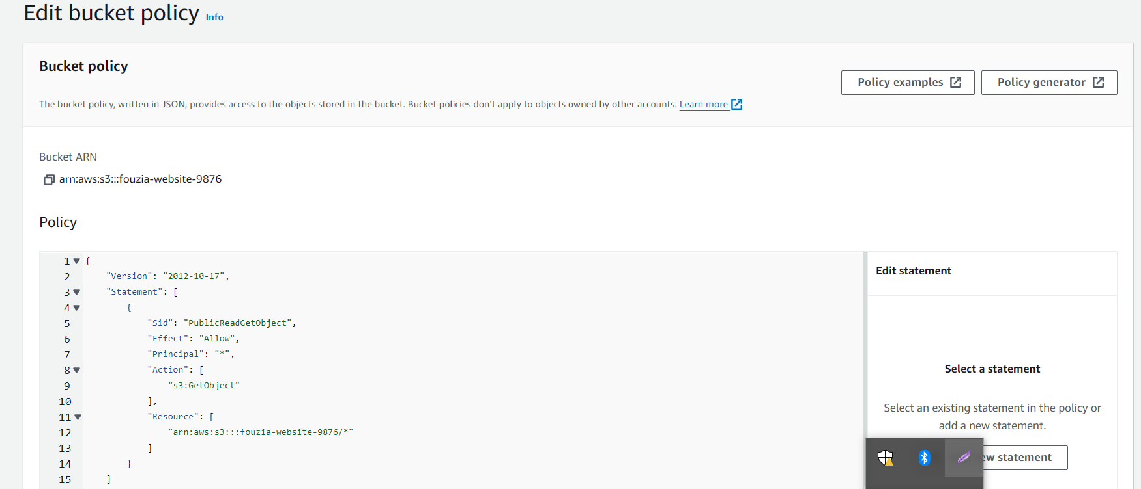

1. **Create and upload the website assets and test the website**

* **Create the website assets**

Create the *index.html* file. This file serves as the initial landing page for the website.

* Opening a text editor.
* Copying the following HTML code.

<!DOCTYPE html>

<html lang="en">

<head>

<meta charset="UTF-8">

<meta name="viewport" content="width=device-width, initial-scale=1.0">

<title>Amazon S3 Static Website</title>

<style>

@font-face {

font-family: 'AmazonEmber';

src: url('https://m.media-amazon.com/images/G/01/AUIClients/AmazonUIFont-amazonember_rg-cc7ebaa05a2cd3b02c0929ac0475a44ab30b7efa._V2_.woff2') format('woff2');

}

body {

display: flex;

flex-direction: column;

justify-content: center;

align-items: center;

height: 100vh;

margin: 0;

font-family: Arial, sans-serif;

}

img {

max-width: 269px;

}

p {

position: absolute;

top: 350px;

text-align: center;

}

</style>

</head>

<body>

<h2>This is an Amazon S3 static website in the cloud!</h2>

<img src="https://d0.awsstatic.com/logos/powered-by-aws.png" alt="Powered by AWS Cloud Computing">

</body>

</html>

* **paste the code.**
* Saving the file as **index.html** to my desktop.

Next, i create the *error.html* file. This webpage is returned when a user enters an incorrect URL for this website.

* In my text editor, creating a new file.
* Copying the following HTML code.

<!DOCTYPE html>

<html lang="en">

<head>

<meta charset="UTF-8">

<meta name="viewport" content="width=device-width, initial-scale=1.0">

<title>Error 404</title>

<style>

@font-face {

font-family: 'AmazonEmber';

src: url('https://m.media-amazon.com/images/G/01/AUIClients/AmazonUIFont-amazonember_rg-cc7ebaa05a2cd3b02c0929ac0475a44ab30b7efa._V2_.woff2') format('woff2');

}

body {

display: flex;

flex-direction: column;

justify-content: center;

align-items: center;

height: 100vh;

margin: 0;

font-family: Arial, sans-serif;

}

h3 {

text-align: center;

}

img {

max-width: 269px;

}

p {

position: absolute;

top: 350px;

text-align: center;

}

</style>

</head>

<body>

<h1>Error 404</h1>

<h3>Oops!<br><br>The URL you entered cannot be found.<br><br>Verify the URL and try again.</h3><br>

<img src="https://d0.awsstatic.com/logos/powered-by-aws.png" alt="Powered by AWS Cloud Computing">

</body>

</html>

* paste the code.
* Saving the file as **error.html** to my desktop.

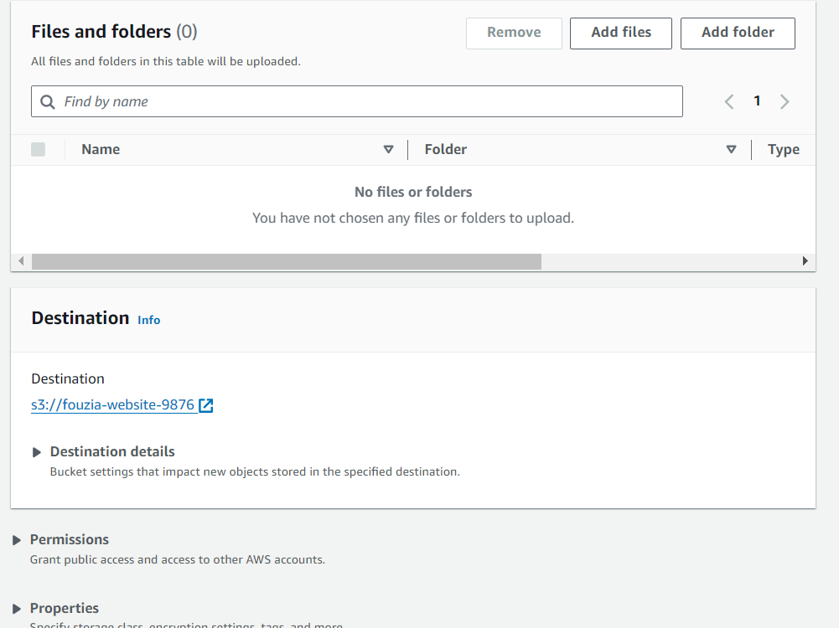

* **Upload the website assets to your bucket**

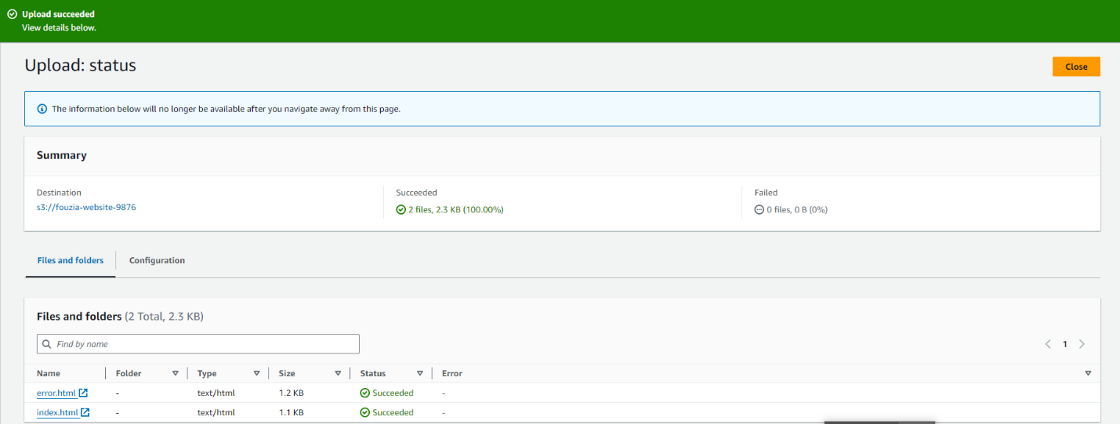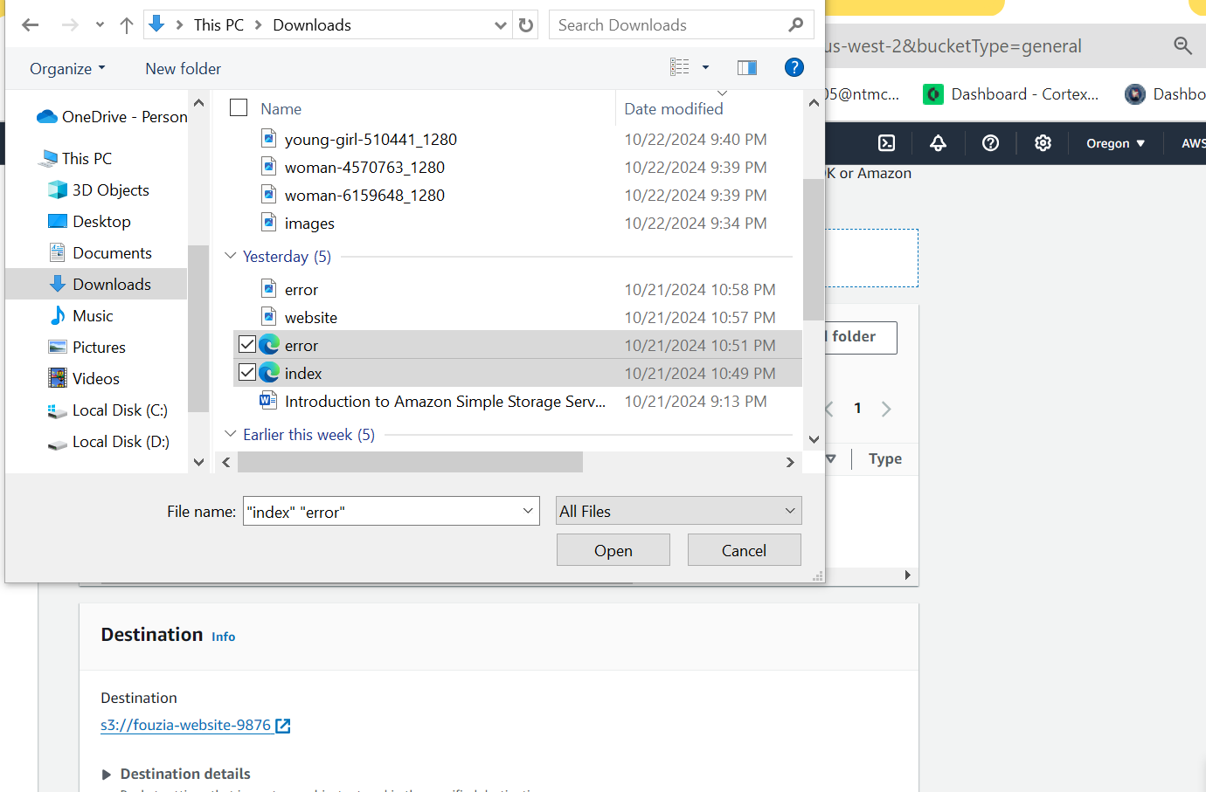

1. **Access the S3 URL**

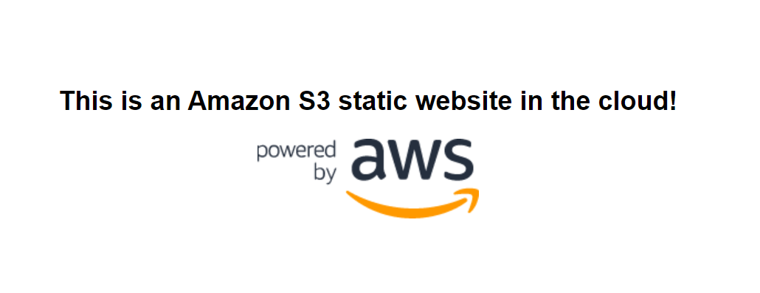

* In the browser’s address bar, go to the end of the URL and add
* /aboutus.html
* to it, and press the **Enter** or **Return** key.

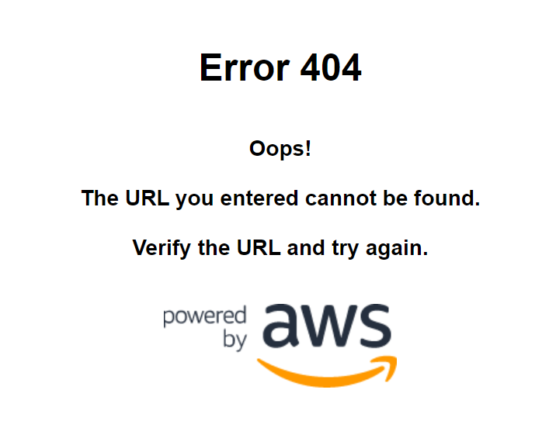The following example is what we can expect the website’s *error.html* page to look like when an incorrect URL is used. 